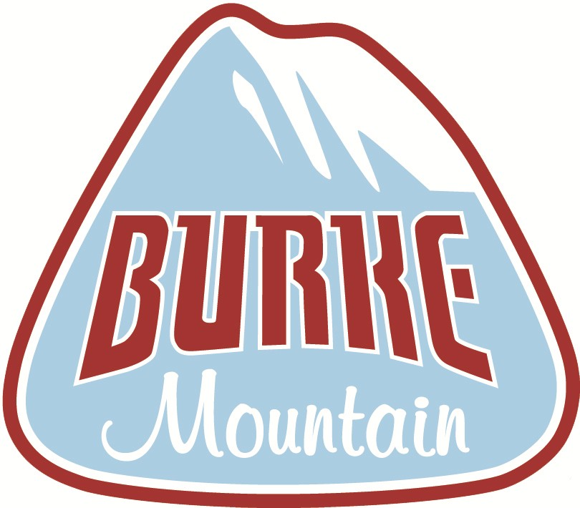

Snow Sports Learning Center

Mini Explorers Program
2024
Ages 3 & 4
Enrollment Packet

Welcome!
The Burke Mountain Snow Sports Learning Center welcomes you to our new 2024 Mini Explorers Program. Our mission is to create an environment where young children can learn proper ski techniques in a safe, fun environment, ensuring a lifetime of winter sport enjoyment. This new program is geared towards younger skiers learning the fundamentals of the sport.

In this Enrollment Packet, you will find the requisite forms needed for registering your child in the program. These forms are to be completed and returned to the Snow Sports Learning Center (see address below). The deadline date for enrollment is January 1, 2024. All enrollments will be processed on a first-come, first-serve basis, and the number of participants will be limited. Please use the information checklist provided below to assist you in making sure all the forms are completed.

We currently have Martin Luther King weekend (January 14) and Presidents weekend (February 18) as holiday blackout dates.

If you have any questions, please contact the Snow Sports Learning Center at (802) 626-7348 or snowsportsdesk@skiburke.com through the end of 2020-21 winter season. The Snow Sports Learning Center is closed during the off-season months but will reopen November 1, 2021. During the off-season, please direct all inquiries to Guest Relations at (802) 626-7300 or info@skiburke.com.

Completed packets may be submitted via email to info@skiburke.com or by mail to the following address:
Burke Mountain
223 Sherburne Lodge Rd. East Burke, VT 05832
Attn: Snow Sports Learning Center
In addition to the completed packet, payment must be made to the Guest Relations office in order to secure your enrollment. Payment can be made via credit card over the phone (see Guest Relations number above), or by check made out to Burke Mountain Operating Co and mailed to the above address. Be advised the cost of the Mini Explorers Program is tiered like that of our Season Passes, and full payment must be received by the end date of each tier in order to receive the respective tier price.

Information Checklist
Mini Explorers Program Price Schedule & Season Calendar (page 3)
Mini Explorers Program Application (pages 4)
Medical Authorization Form (page 5)

Mini Explorers Program Price Schedule

THE DEADLINE FOR ENROLLMENT IS $399.00

- Explorers Program price does not include lift access.

2021 – 2022 Season Calendar

Session Times
Sundays: 10:00 -11:00am
Sundays: 11:00 –12:00am

Full Season Dates
January 1, 2024 - March 24, 2024

Holiday Blackout Dates
MLK Weekend: January 14, 2024
President’s Day Weekend: February 18, 2024

Mini Explorers Program Application (2024)
Participant’s Name: | Age (As of January 1, 2024): Participant’s Date of Birth: | Male / Female (circle one) Allergies: Parents’ Names: Primary E-Mail Address*:
* Email is our primary mode of communicating with parents for announcements and other important information regarding the Explorers Program throughout the season
Secondary E-Mail Address:
Winter Physical Address: Summer Mailing Address:

Home Phone: ( ) Cell Phone: ( ) Alternate Cell: ( ) Condo Phone: ( )
Full Season (10 weeks)

Half Season (1st 5 weeks)

Ability Level Placement
Red: First timers learn about equipment, balance, moving, stopping, and turning.
J-Bar Green: Skiers and riders with equipment knowledge, can stop, and have started linking multiple turns using a wedge to control speed and turn shape.
Sherburne Green: Skiers and riders are successfully linking turns. Skiers are making parallel turns about 80% of the time, and will improve on posture, be introduced to steep terrain and pole plants. Riders can transition between both toe and heel edges and will be introduced to switch riding.

Medical Authorization
CHILD’S NAME:
(Last Name) (First Name) (MI) MEDICAL INSURANCE COMPANY:
POLICY #:

PRIMARY EMERGENCY CONTACT NAME: PHONE: RELATION:
SECONDARY EMERGENCY CONTACT NAME: PHONE: RELATION:

I, the undersigned, authorize anyone working for Burke Mountain Resort to call for such medical care for the above named child and/or to transport the child to the appropriate clinic or hospital; and if in the opinion of anyone working for Burke Mountain Resort medical attention is required for the child, this authorizes a licensed physician or other recognized first aid staff member to carry out emergency medical care deemed necessary for my child/ward in an emergency where normal permission is unavailable.

I, the undersigned, agree that upon transporting the child to any medical facility, clinic, or hospital that the responsibility of Burke Mountain Resort shall be totally fulfilled, and Burke Mountain Resort shall not have any further responsibility for the child.

I, the undersigned, agree to pay all costs associated with such medical care and related transportation for the child, and indemnify and hold Burke Mountain Resort, its subsidiaries and affiliates, their respective agents, officers, directors, owners, contractors and employees (collectively, the “Released Parties”) harmless for any costs incurred therein.

I have carefully read this release and understand its content and language.

For himself or herself as individuals, and as parent or guardian of the child, does the child have the following:
- MEDICAL CONDITIONS:
- ALLERGIES:
- MEDICATIONS:

Parent / Guardian Signature: Parent / Guardian Name (PRINT):

