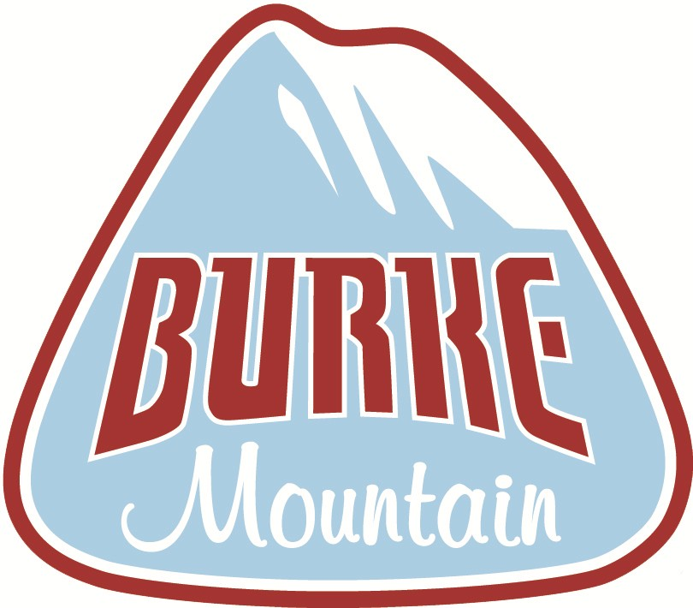

Snow Sports Learning Center

Mini Explorers Program
2024
Ages 3 & 4
Enrollment Packet

Welcome!
The Burke Mountain Snow Sports Learning Center welcomes you to our new 2024 Mini Explorers Program. Our mission is to create an environment where young children can learn proper ski techniques in a safe, fun environment, ensuring a lifetime of winter sport enjoyment. This new program is geared towards younger skiers learning the fundamentals of the sport.

In this Enrollment Packet, you will find the requisite forms needed for registering your child in the program. These forms are to be completed and returned to the Snow Sports Learning Center (see address below). The deadline date for enrollment is January 1, 2024. All enrollments will be processed on a first-come, first-serve basis, and the number of participants will be limited. Please use the information checklist provided below to assist you in making sure all the forms are completed.

We currently have Martin Luther King weekend (January 14) and Presidents weekend (February 18) as holiday blackout dates.

If you have any questions, please contact the Snow Sports Learning Center at (802) 626-7348 or snowsportsdesk@skiburke.com through the end of 2024 winter season.
In addition to the completed packet, payment must be made to the Guest Relations office in order to secure your enrollment. Payment can be made via credit card over the phone (see Guest Relations number above.)

Information Checklist
Mini Explorers Program Price Schedule & Season Calendar (page 3)
Mini Explorers Program Application (pages 4)
Medical Authorization Form (page 5)

Mini Explorers Program Price Schedule

Price: $399.00

THE DEADLINE FOR ENROLLMENT IS January 1, 2024

- Explorers Program price does not include lift access.

2021 – 2022 Season Calendar

Session Times
Sundays: 10:00 -11:00am
Sundays: 11:00 –12:00am

Full Season Dates
January 1, 2024 - March 24, 2024

Holiday Blackout Dates
MLK Weekend: January 14, 2024
President’s Day Weekend: February 18, 2024

Mini Explorers Program Application (2024)
Participant’s Name: | Age (As of January 1, 2024): Participant’s Date of Birth: | Male / Female (circle one) Allergies: Parents’ Names: Primary E-Mail Address*:
* Email is our primary mode of communicating with parents for announcements and other important information regarding the Explorers Program throughout the season
Secondary E-Mail Address:
Winter Physical Address: Summer Mailing Address:

Home Phone: ( ) Cell Phone: ( ) Alternate Cell: ( ) Condo Phone: ( )
Full Season (10 weeks)

Ability Level Placement
Red: First timers learn about equipment, balance, moving, stopping, and turning.
J-Bar Green: Skiers and riders with equipment knowledge, can stop, and have started linking multiple turns using a wedge to control speed and turn shape.
Sherburne Green: Skiers and riders are successfully linking turns. Skiers are making parallel turns about 80% of the time, and will improve on posture, be introduced to steep terrain and pole plants.

